Question – 1 [CLO3]
An exam question required to compute the checksum for the following 16-bit words:
FFFF 8001 7FFE 0001
A student calculates checksum to be FFFF before sending to the receiver.
- Verify this calculation. Show complete working at the sender side [4]
- In case it is NOT correct, list down the mistake and compute the correct checksum and verify your answer at the receiver end (show complete working) [2,4]
- The student argues that FFFF is all 1s, so it must be correct. Do you agree with his reasoning to be valid? Justify your answer. [5]
SOLUTION
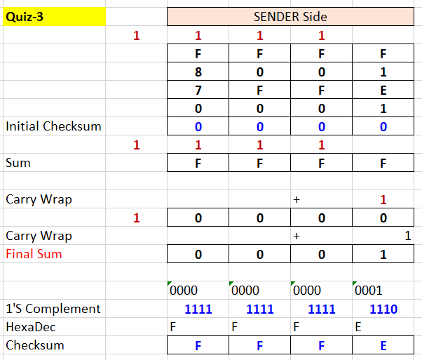
Mistake was the incorrect calculation of checksum due to ignoring the additional carry which was not wrapped around by the student. Correct checksum = FFFE
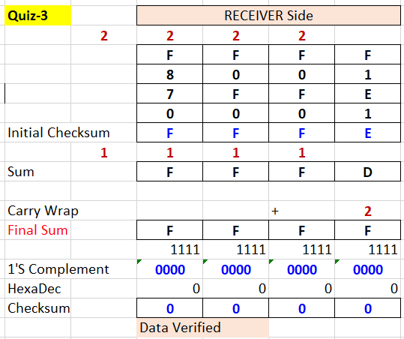
The student’s reasoning is incorrect. Getting FFFF as a checksum is not automatically correct The student ignored Correct handling of carry wraparound FFFF is the expected result only after verification, not necessarily as a checksum value

